**SEARCH RESULTS FOR MAIZE (CORN) FOR FREE STATE, SOUTH AFRICA; OMNI-AI**

**1) Average weather pattern for Free State, South Africa**

* On average, the warmest month(s) are January, February and December.
* Bloemfontein has dry periods in May, June, July, August, September and October.
* On average, the warmest month is January.
* On average, the coolest month is July.
* March is the wettest month. This month should be avoided if you don't like too much rain.
* July is the driest month

**2) Rainfall pattern for Free State, South Africa**

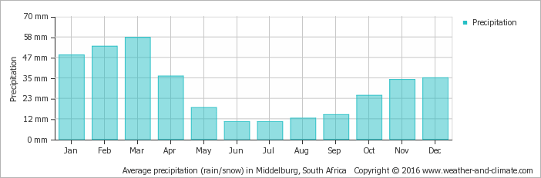

[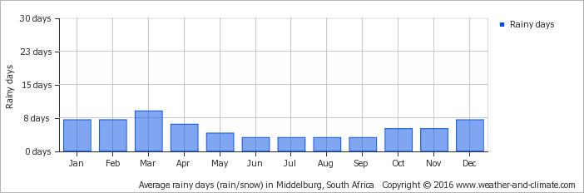](https://weather-and-climate.com/average-monthly-Rainy-days,bloemfontein,South-Africa)

**3) Average amount of rainfall in mm for Free State, South Africa**

500 mm of rain

**4) Average regional climate for Free State, South Africa**

Rainy summers, frigid winters, lots of sunshine

* Average summer **temperature** is +/- 23ºC
* Average winter **temperature** is +/- 8ºC
* January is the hottest month with a **temperature** range of 15 - 32ºC
* June is the coldest, its range a cold 1ºC to a mild 17ºC

**5) Specific natural disasters that affect Free State, South Africa**

* Drought
* Flooding

**6) Frequency of the above Natural disasters in Free State, South Africa**

* Flooding: High during the summer raining season from January to March
* Drought: Likelihood from June to September

**7) General soil type in Free State, South Africa**

* Light sandy soil

**8) Best propagation or farming methods for maize in Free State, South Africa**

* Mostly mechanized farming with irrigation
* *Crop rotation with sunflower, groundnuts and dry beans*
* Mixed farming with cattle on the off season is also recommended

**9) Historical planting time for maize in Free State, South Africa.**

December

**10) Best planting time for maize in Free State, South Africa.**

January

**11) Historical Harvesting time for maize in Free State, South Africa.**

May

**12) Best Harvesting time for maize in Free State, South Africa**

June

**13) Top two natural fertilizer options for maize in Free State, South Africa**

* Chicken Manure
* Cattle Manure

**14) Top two chemical fertilizer options for maize in Free State, South Africa**

* NPK fertilizers

**15) Common Maize crop disease to expect during the farming season in Free State, South Africa**

* Grey leaf spot
* Stem rot
* Cob rot
* Root rot
* Cob and tassel smut

**16) Top three Maize crop diseases to expect during the farming season in Free State, South Africa**

* Grey leaf spot
* Stem rot
* Cob and tassel smut

**17) Common Maize crop pests to expect during the farming season in Free State, South Africa**

* Nematodes
* Aphids
* Fall Armyworm

**18) Top three** **Maize crop pests to expect during the farming season in Free State, South Africa**

* Fall Armyworms
* Nematodes
* Aphids

**19) Best soil type for maize in Free State, South Africa**

Light sandy soil with a clayey base

**20) Agric policy in direct relation to Maize farming in Free State, South Africa**

* No direct agirc policy benefiting maize farmers

**21) Type of government subsidy for maize in Free State, South Africa**

* No known Government subsidy geared directly towards maize.

**22) Lowest Market price over the past three years for Maize in Free State, South Africa**

* R 60 for Yellow Corn 50kg per bag
* R 80 for White Corn 50kg per bag

**23) Highest Market price over the past three years for Maize in Free State, South Africa**

* R 160 for Yellow Corn 50kg per bag
* R 200 for White Corn 50kg per bag

**24) Best Market over the past two years for Maize in Free State, South Africa**

* R 80 for Yellow Corn 50kg per bag
* R 160 for White Corn 50kg per bag

**25) Historically best month to sell harvested maize in Free State, South Africa**

* May

**26) Top two areas of demand for maize in Free State, South Africa**

* Free State Province
* Northern West Province

**27) Top countries of demand for** **maize from Free State, South Africa**

* Spain
* Botswana
* Congo
* France
* Mexico
* Ghana
* Namibia

**28) Best storage option for each harvested Maize grains in Free State, South Africa.**

* **For medium to large scale commercial farmers**: Store in mechanized silos with moisture control and grain drying features.

This is done either on-site at the farm or commercial co-operative or a maize storage companies.

* **For small holder farmers**: Drying adequately in the sun and storing in bags in areas where they are protected from rain and moisture.

**29) General life cycle of Maize in Free State, South Africa**

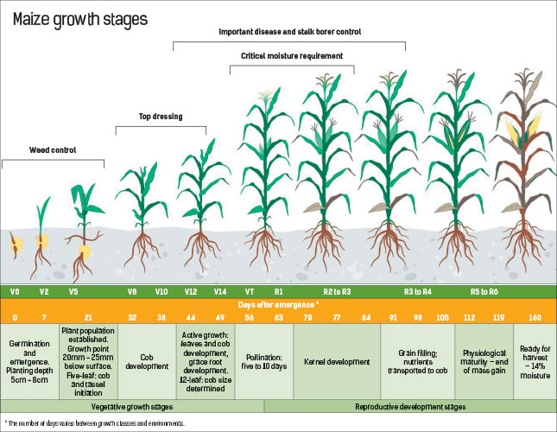

30) Top three varieties of each crop

* Grace
* ZM521
* TELA (New Variety)

**31) Dealing with weeds in Free State, South Africa.**

* Pig weed, khaki weed, wild lucerne, horse weed and Senecio sp. are common problem plants.
* Finger grass is a serious problem in maize lands late in the season.
* Weeds are sprayed off a week before planting and again after planting.